**sporty-shoes**

**Developer**

Murtaza Merchant

**Overview**

Sporty Shoes is a company that manufactures and sells sports shoes. They have a walk-in store, and now, they wish to launch their e-commerce portal sportyshoes.com.

**Tools Used**

1. Eclipse: An IDE to code for the application
2. Java: A programming language to develop the prototype
3. MySQL: To create tables for admin, classes, students, and other specifics
4. Maven: A build tool for adding all the external dependencies
5. Git: To connect and push files from the local system to GitHub
6. GitHub: To store the application code and track its versions

**Data Structures & Techniques Used**

1. Spring Boot : Popular Java Framework to acheive inversion of control and dependency injection
2. Spring MVC : Model View Controller by Spring
3. Spring Security : To manage user logins and restrict access based on user roles.
4. Thymeleaf : A popular template engine to design view layer

**Admin Flow Chart**

[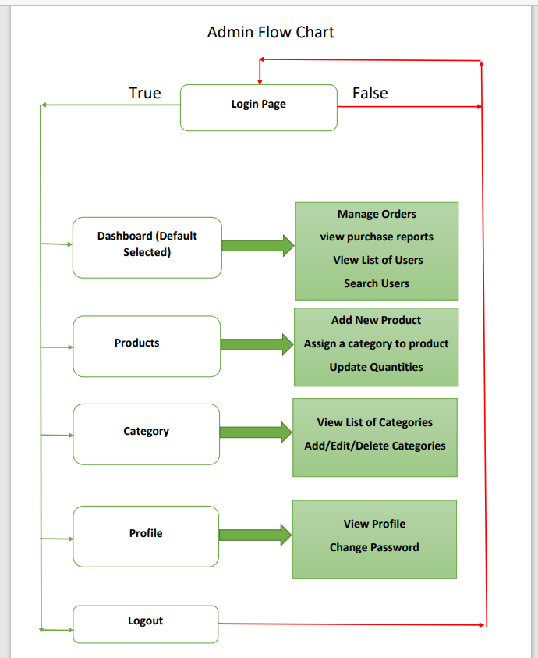](https://github.com/mcvrvikram/sporty-shoes/blob/main/SportyShoes/Adminflow.PNG)

**User Flow Chart**

[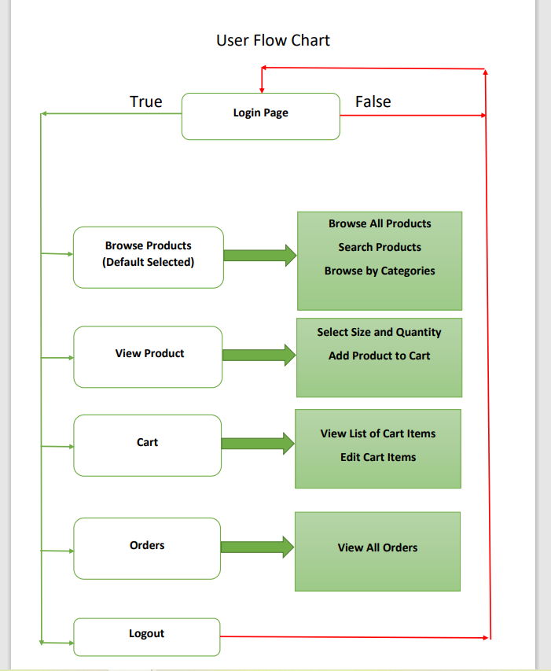](https://github.com/mcvrvikram/sporty-shoes/blob/main/SportyShoes/userFlow.PNG)

**Sample Output**

**Sample 1**

[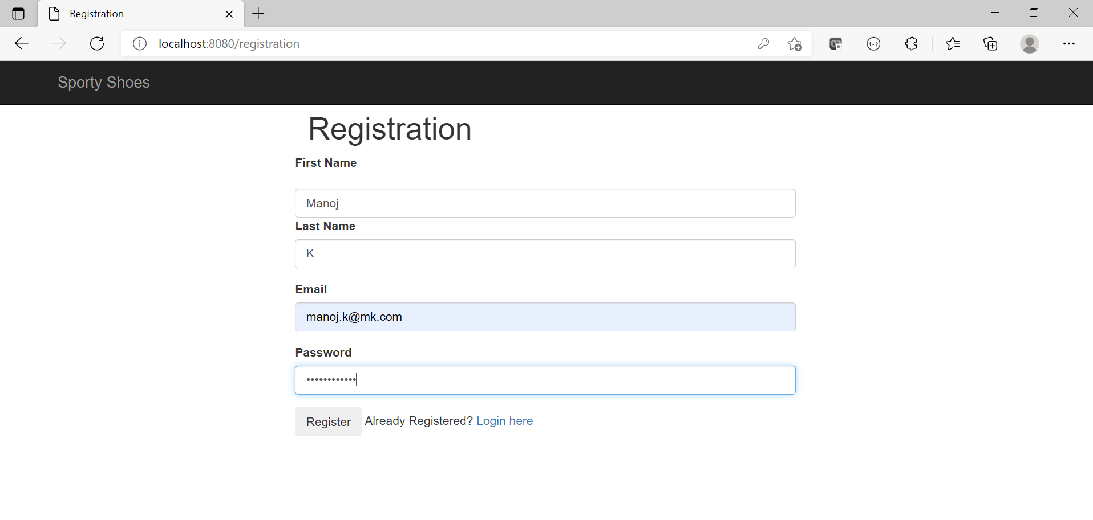](https://github.com/mcvrvikram/sporty-shoes/blob/main/SportyShoes/1registration.PNG)

**Sample 2**

[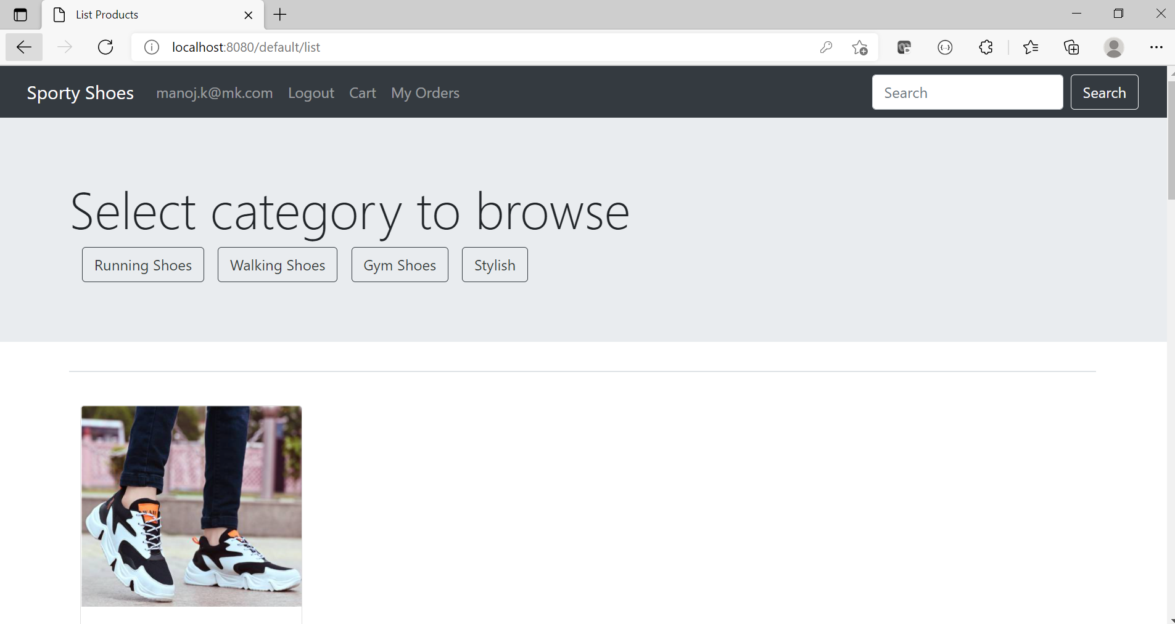](https://github.com/mcvrvikram/sporty-shoes/blob/main/SportyShoes/2products.PNG)

**Sample 3**

[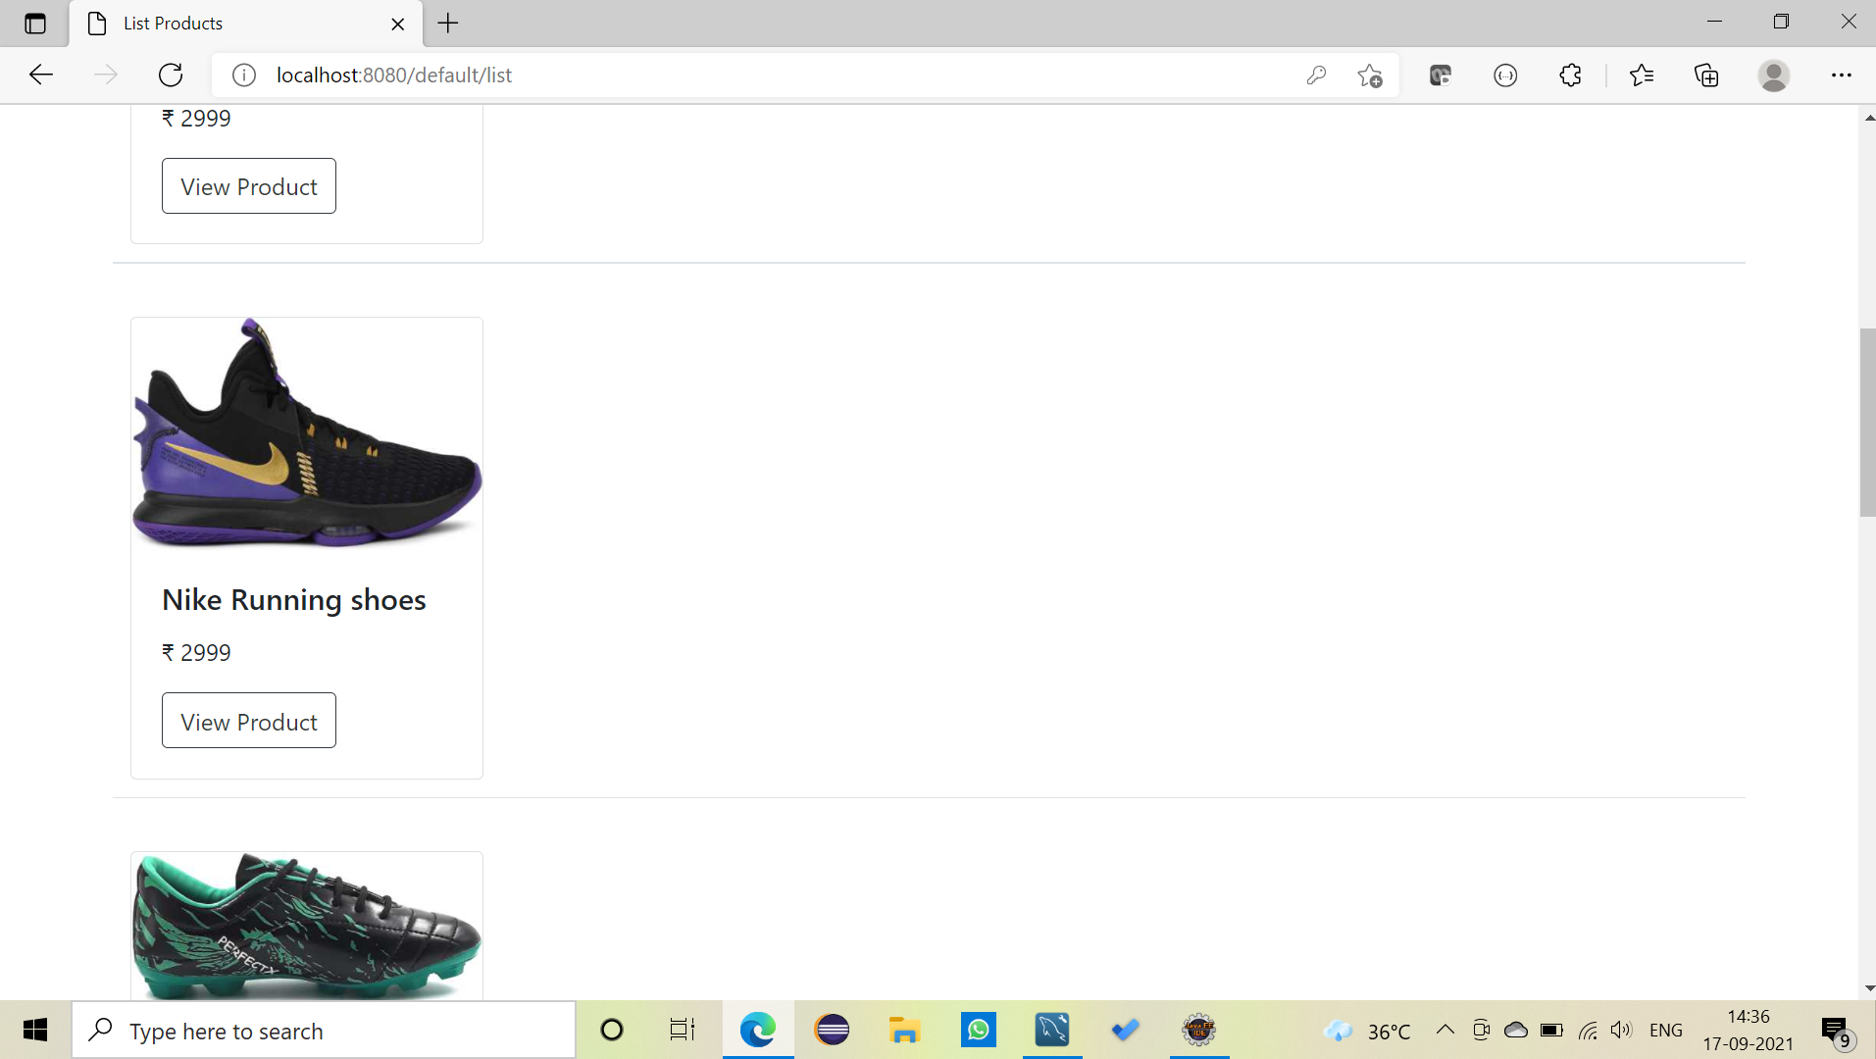](https://github.com/mcvrvikram/sporty-shoes/blob/main/SportyShoes/3product.PNG)

**Sample 4**

[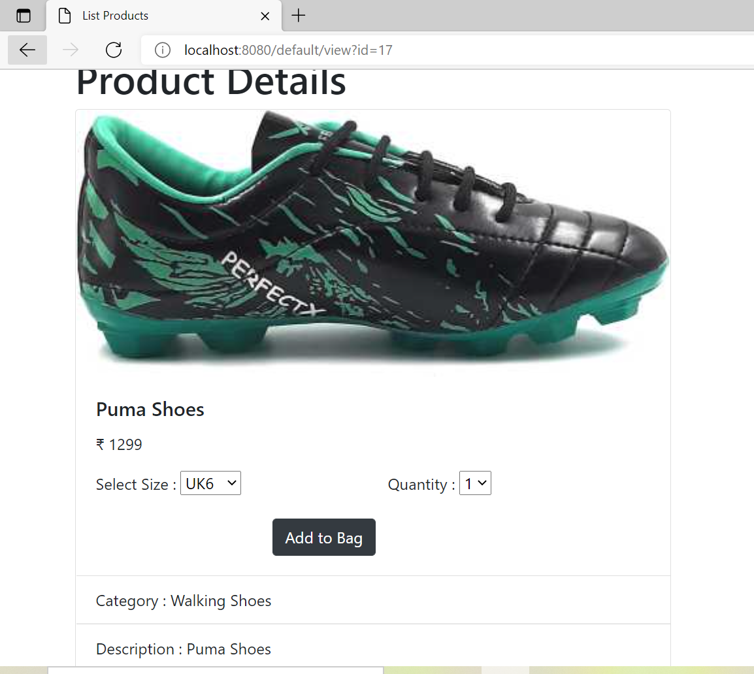](https://github.com/mcvrvikram/sporty-shoes/blob/main/SportyShoes/4product.PNG)

**Sample 5**

[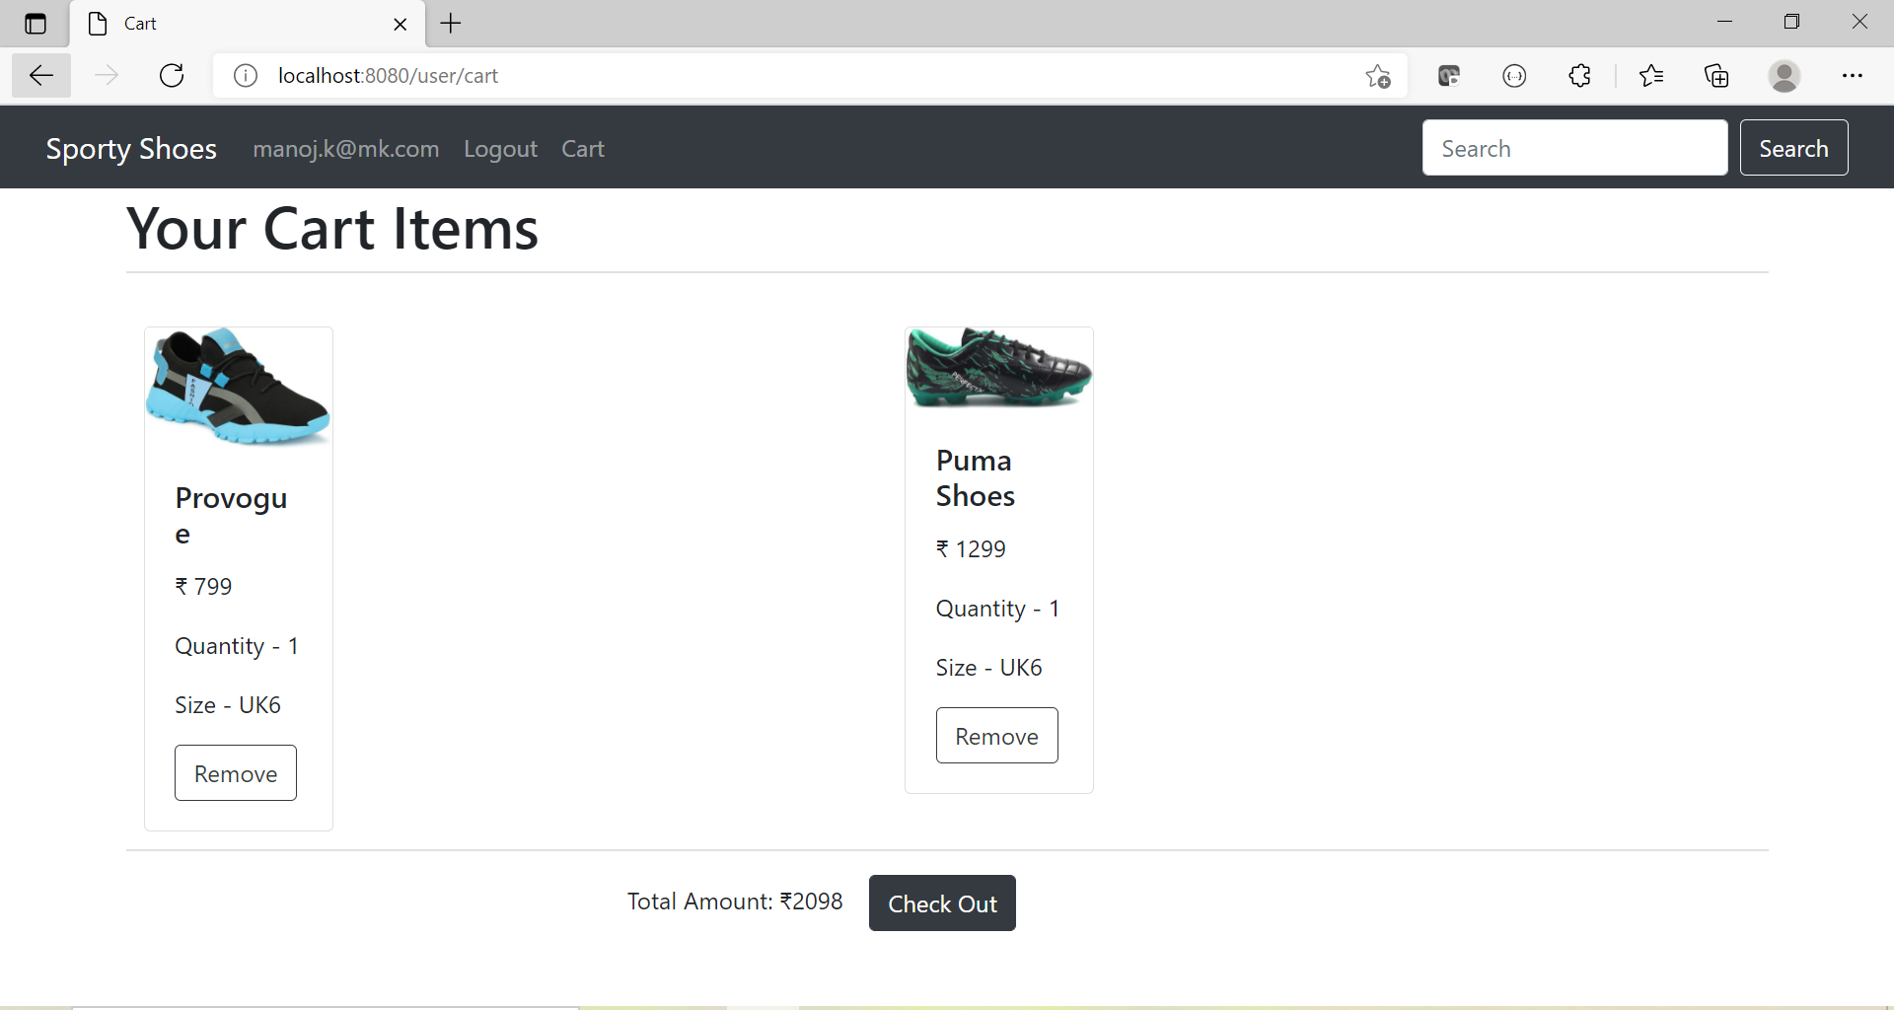](https://github.com/mcvrvikram/sporty-shoes/blob/main/SportyShoes/5product.PNG)

**Sample 6**

[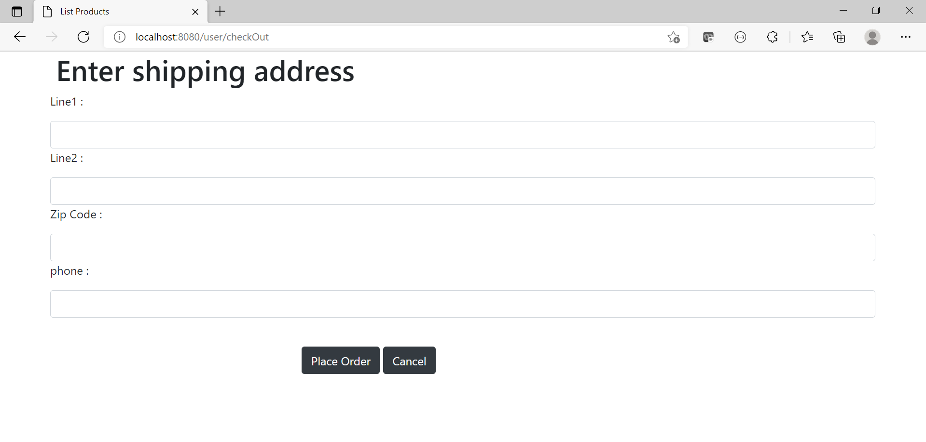](https://github.com/mcvrvikram/sporty-shoes/blob/main/SportyShoes/5checkOut.PNG)

**Sample 7**

[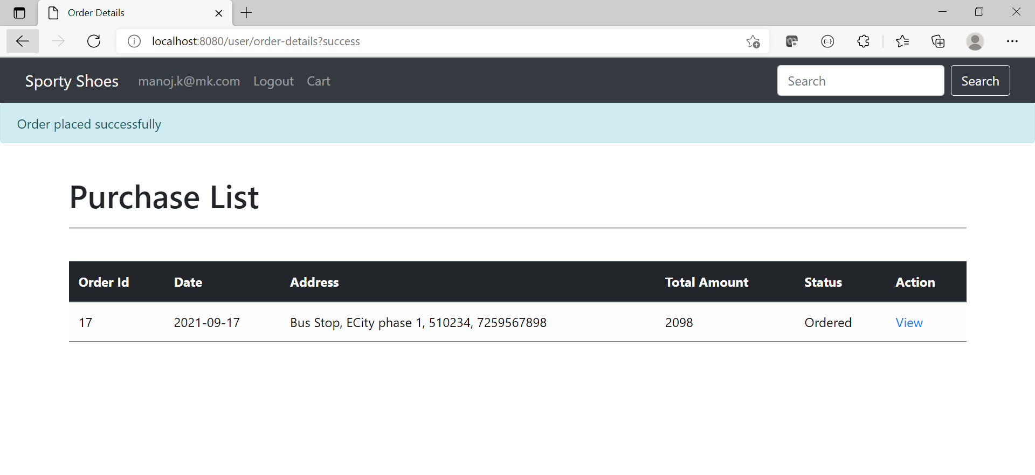](https://github.com/mcvrvikram/sporty-shoes/blob/main/SportyShoes/6orderDetails.PNG)

**Sample 8**

[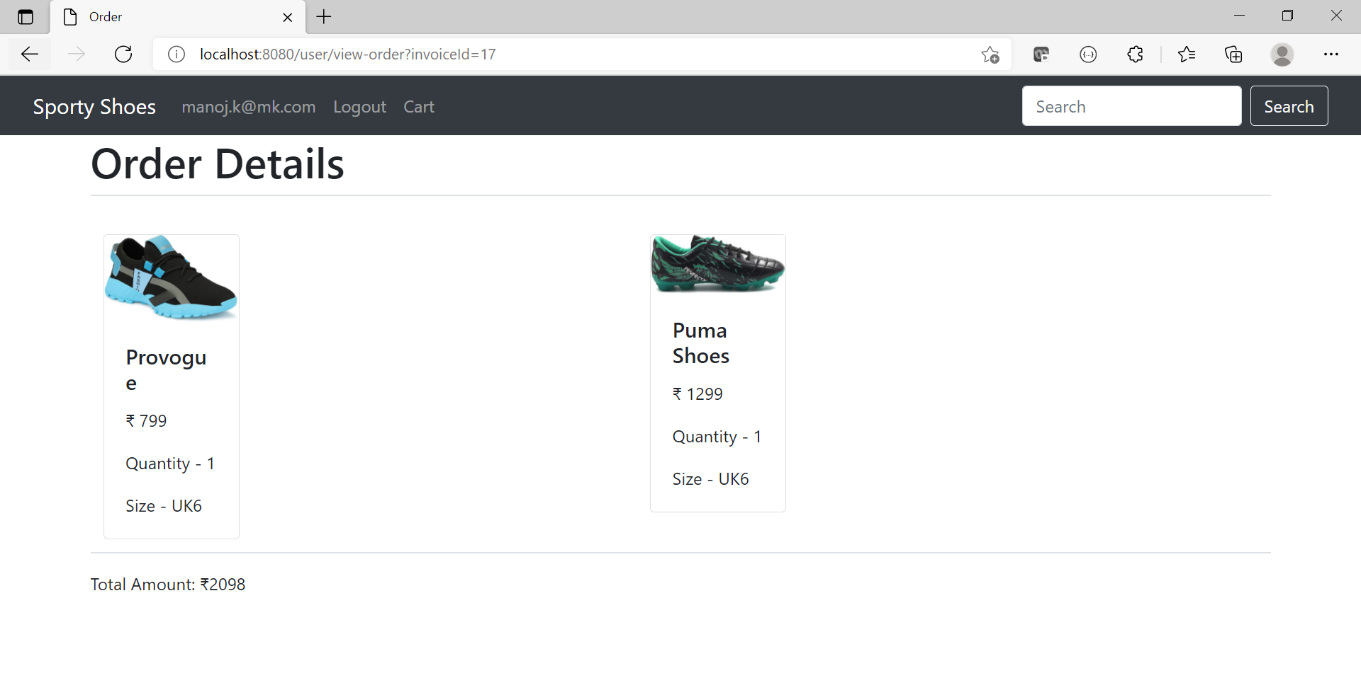](https://github.com/mcvrvikram/sporty-shoes/blob/main/SportyShoes/7orderDetails.PNG)

**Sample 9**

[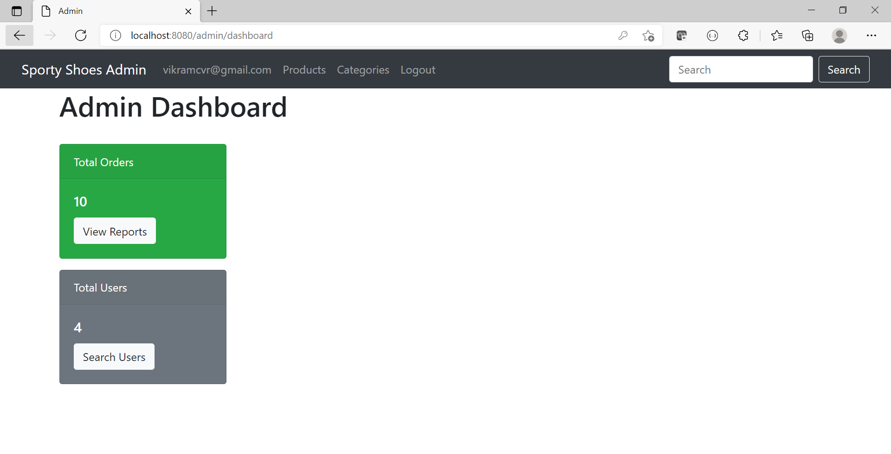](https://github.com/mcvrvikram/sporty-shoes/blob/main/SportyShoes/8admin.PNG)

**Sample 10**

[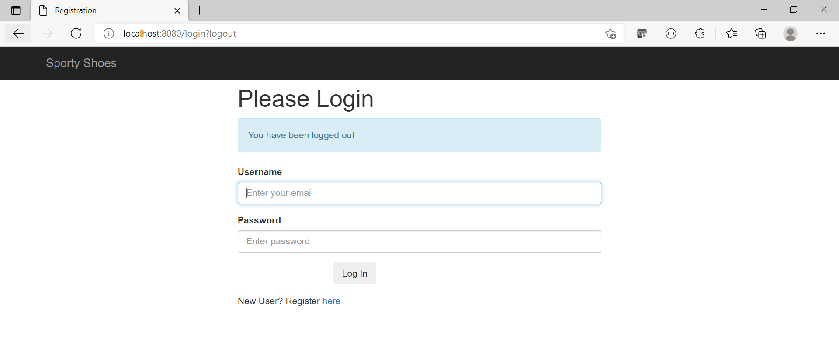](https://github.com/mcvrvikram/sporty-shoes/blob/main/SportyShoes/8loggedOut.PNG)

**Sample 11**

[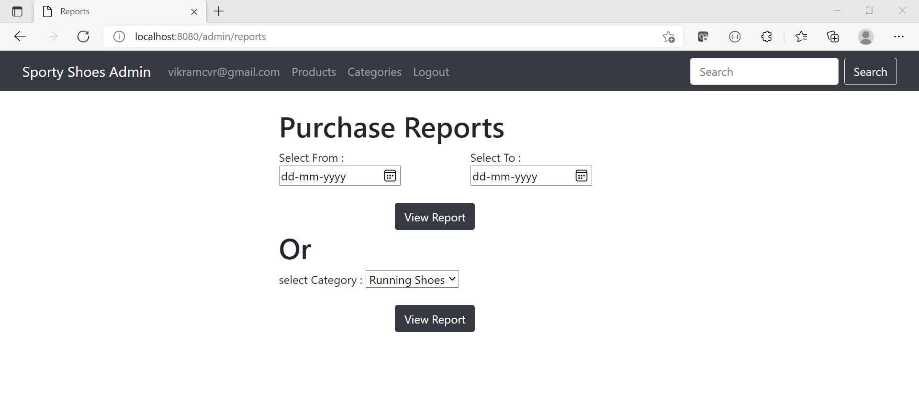](https://github.com/mcvrvikram/sporty-shoes/blob/main/SportyShoes/9reports.PNG)

**Sample 12**

[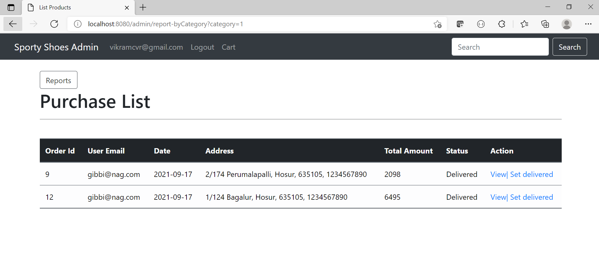](https://github.com/mcvrvikram/sporty-shoes/blob/main/SportyShoes/10Reports.PNG)

**Sample 13**

[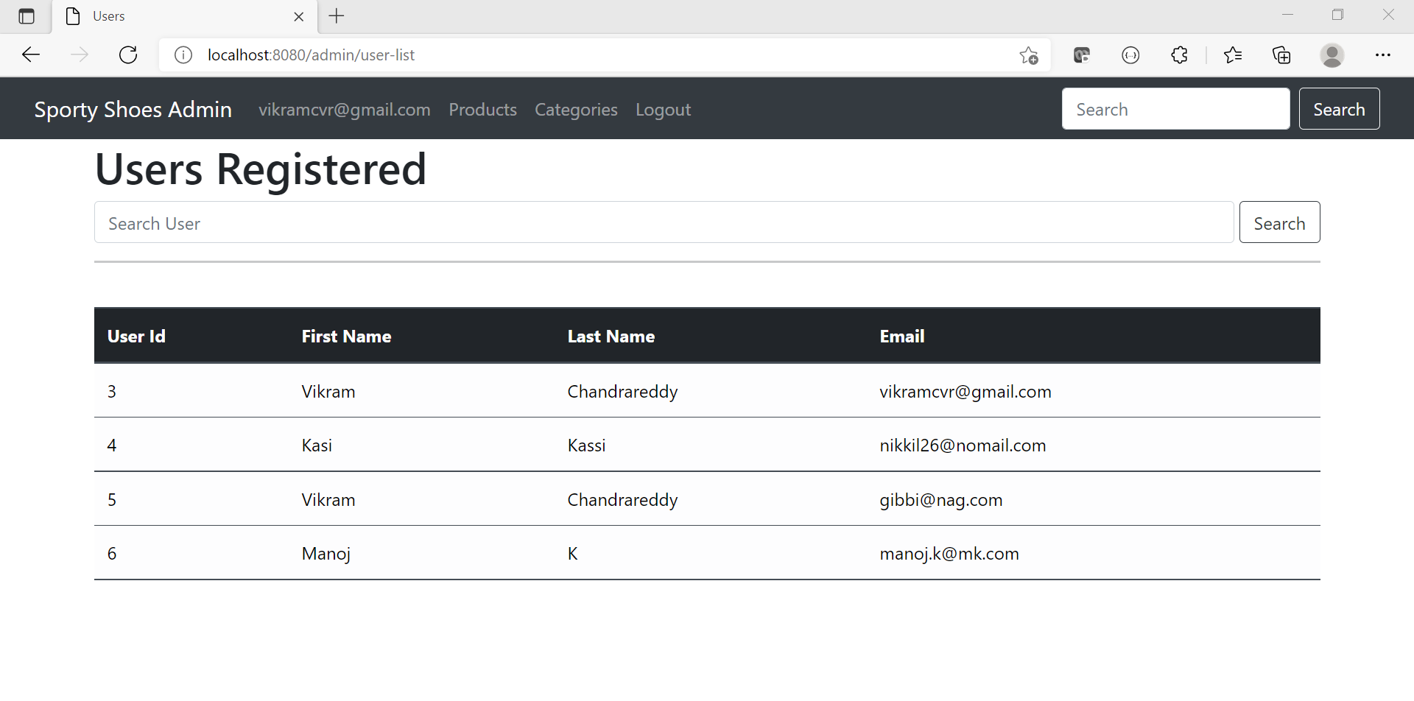](https://github.com/mcvrvikram/sporty-shoes/blob/main/SportyShoes/11listUsers.PNG)

**Sample 14**

[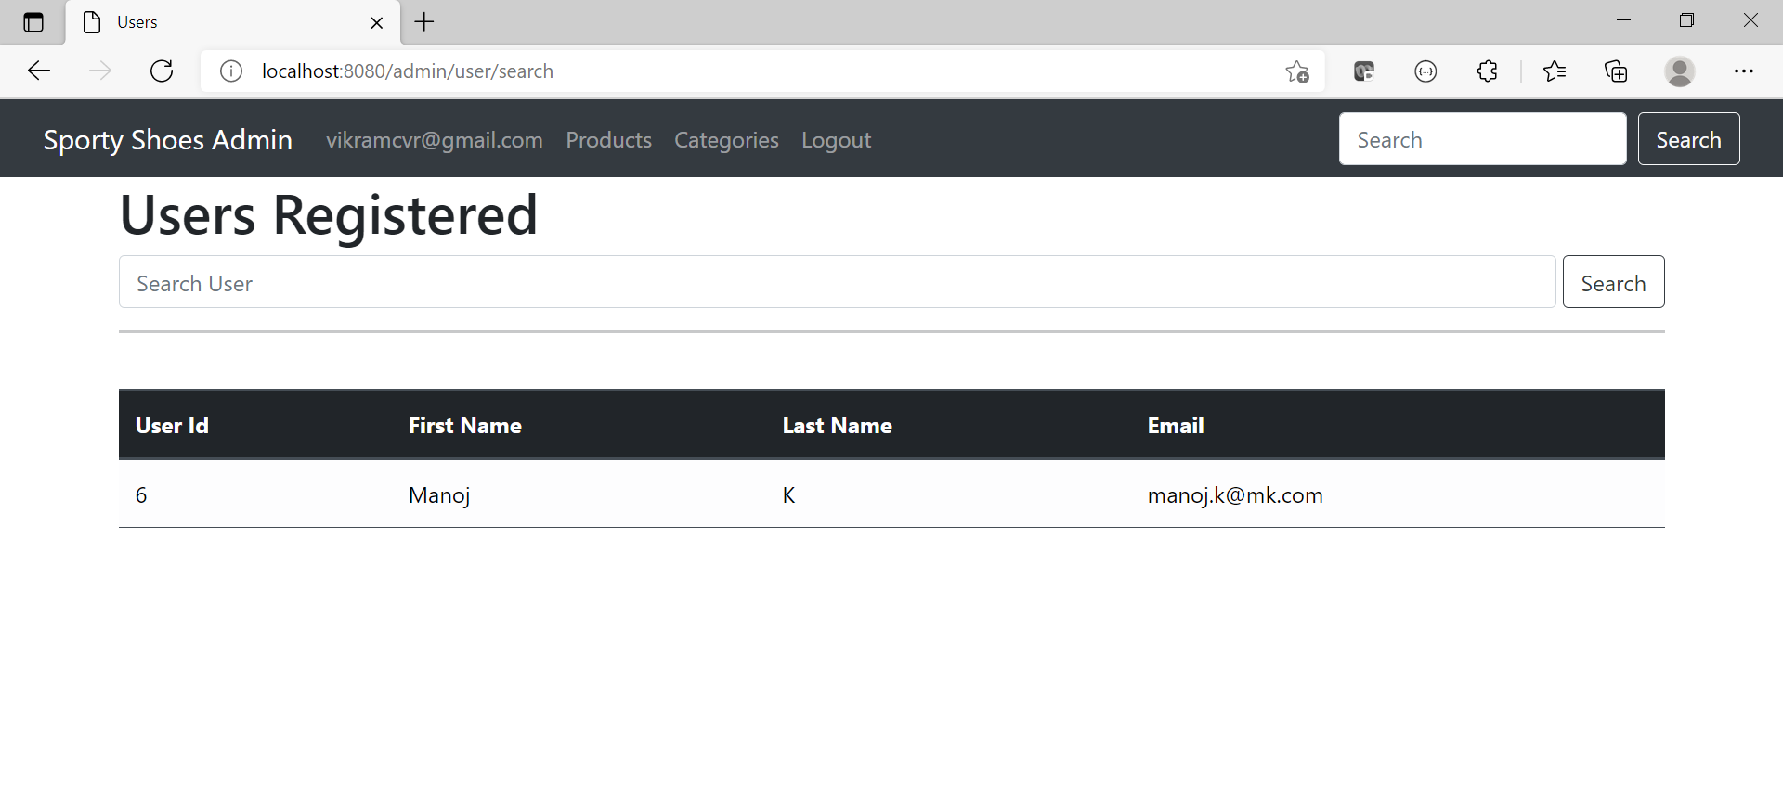](https://github.com/mcvrvikram/sporty-shoes/blob/main/SportyShoes/12SearchUser.PNG)

**Sample 15**

[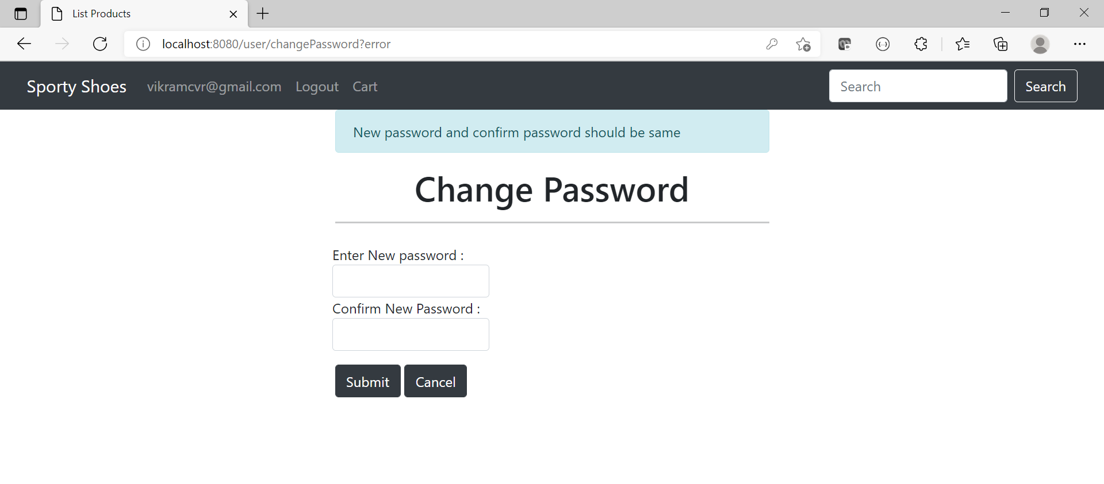](https://github.com/mcvrvikram/sporty-shoes/blob/main/SportyShoes/13chagepwd.PNG)

**Sample 16**

[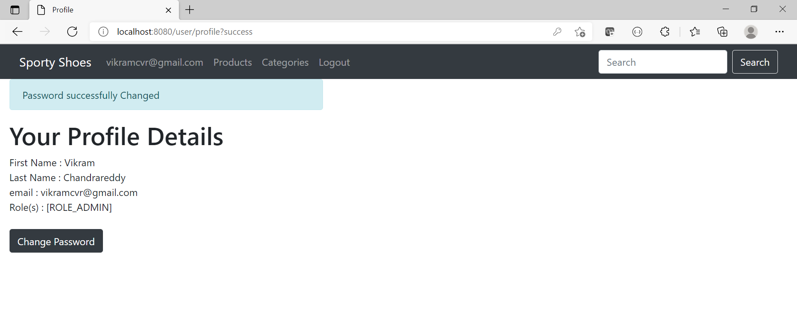](https://github.com/mcvrvikram/sporty-shoes/blob/main/SportyShoes/14changepwd.PNG)

**Sample 17**

[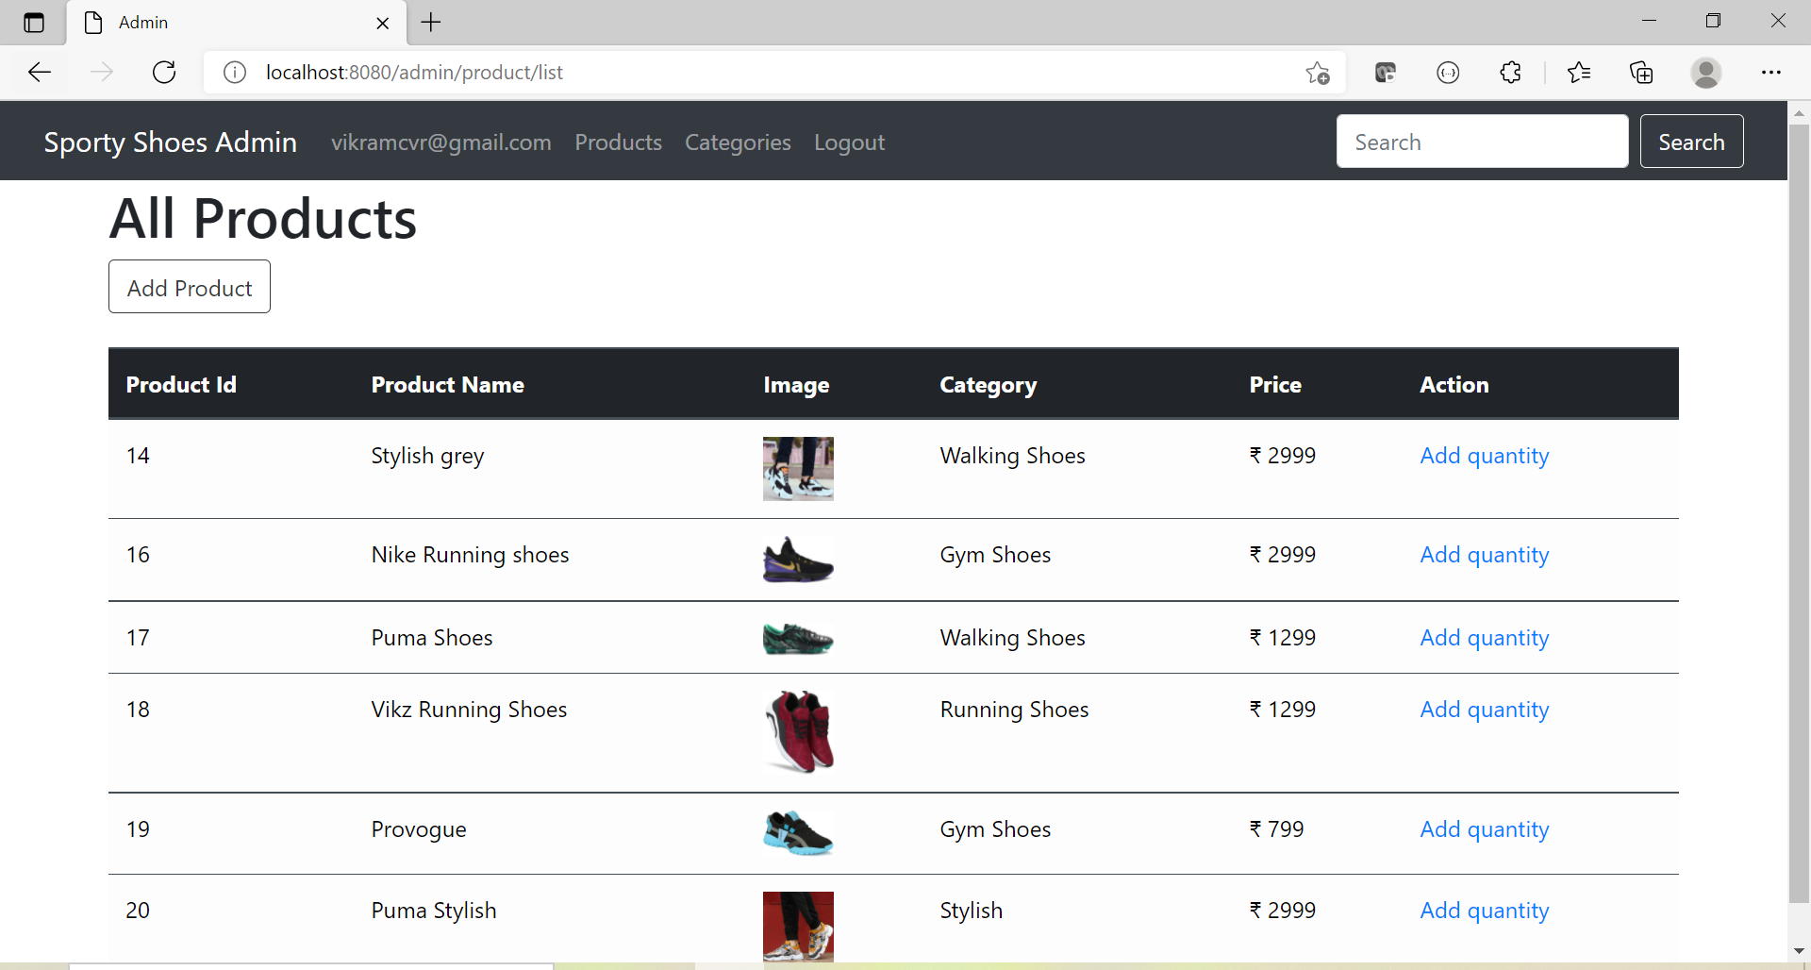](https://github.com/mcvrvikram/sporty-shoes/blob/main/SportyShoes/15AddProd.PNG)

**Sample 18**

[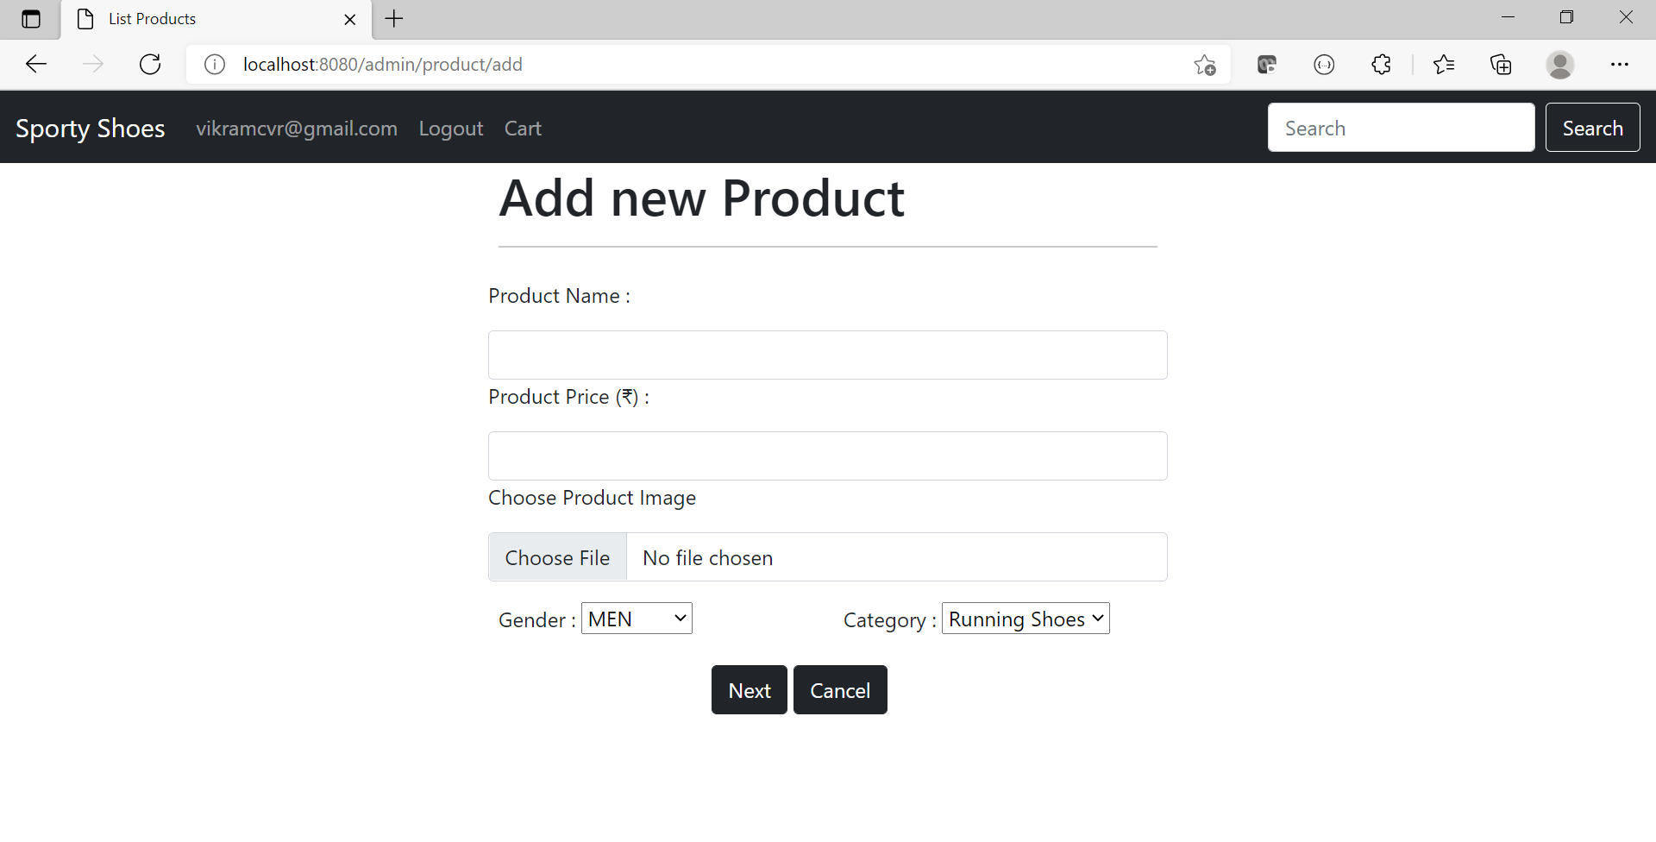](https://github.com/mcvrvikram/sporty-shoes/blob/main/SportyShoes/16AddProdForm.PNG)

**Sample 19**

[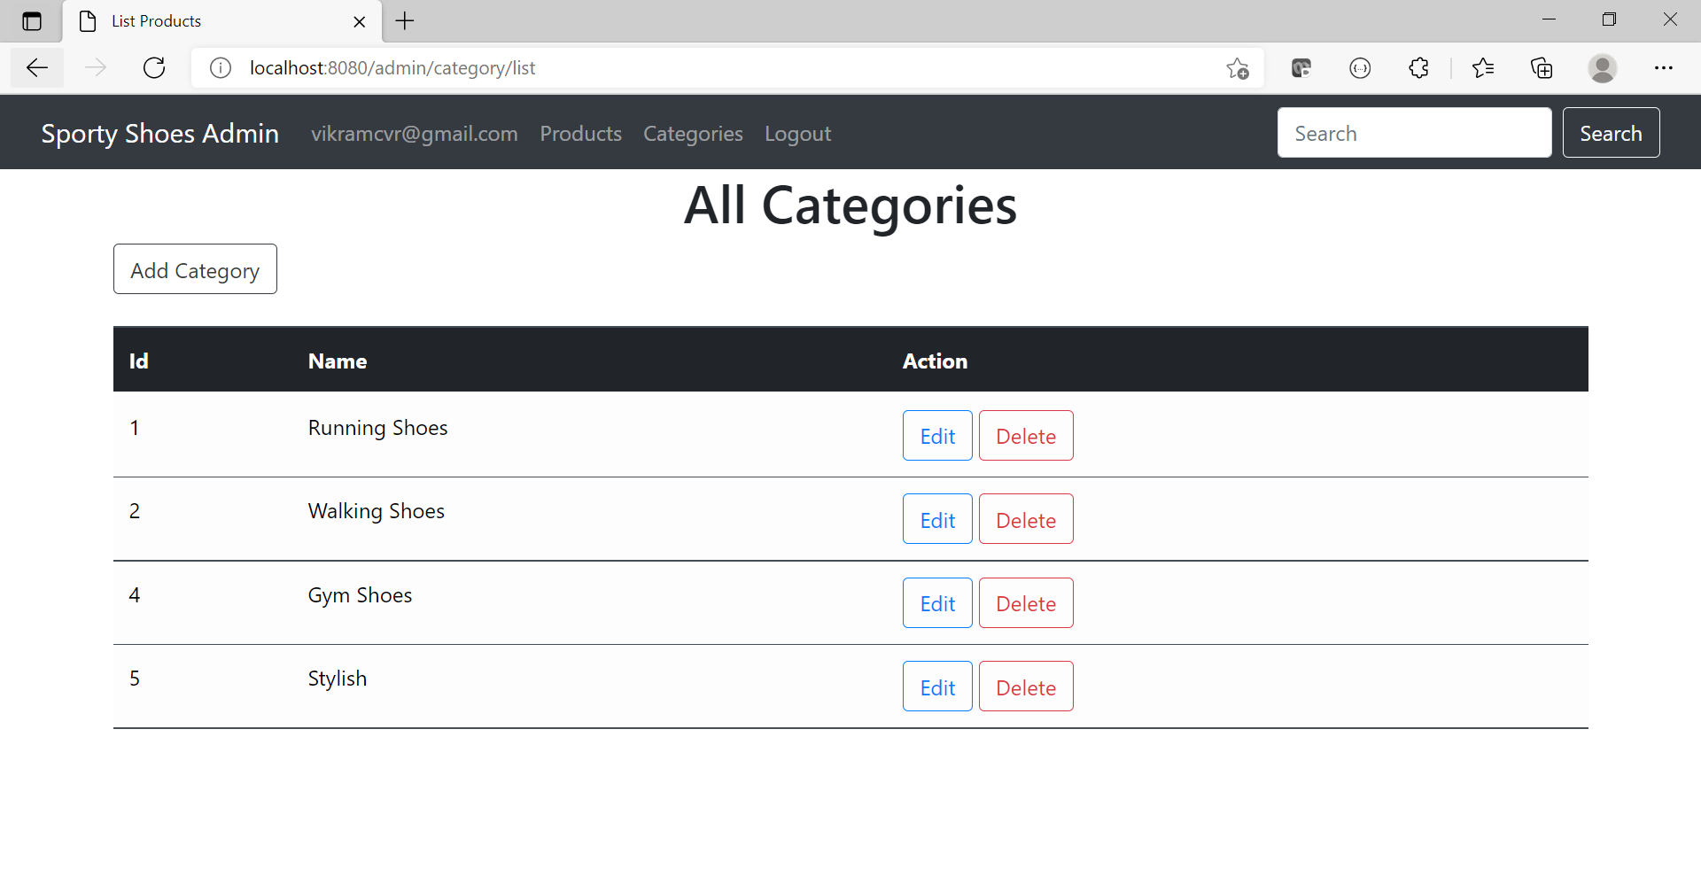](https://github.com/mcvrvikram/sporty-shoes/blob/main/SportyShoes/Category.PNG)

**Sample 20**

[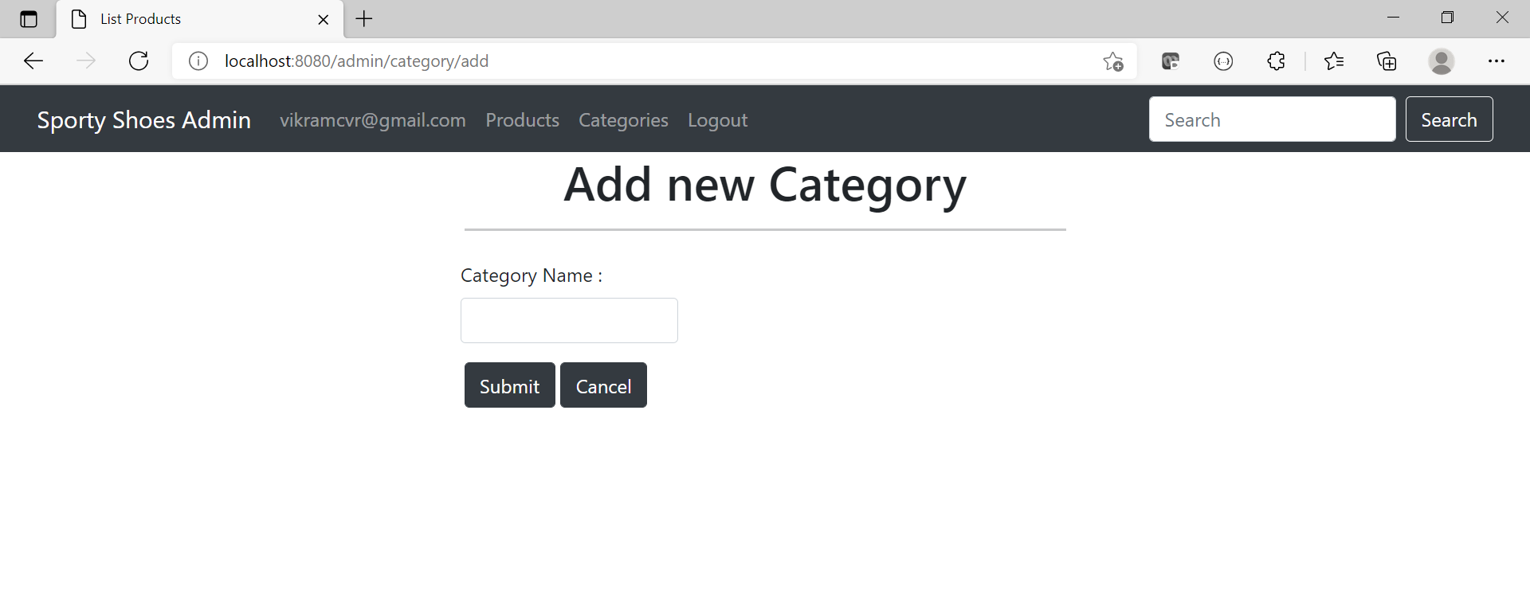](https://github.com/mcvrvikram/sporty-shoes/blob/main/SportyShoes/18Category.PNG)